Statement of environmental effects.
- Site Suitability
Constraints.
Flooding.
Consulted Lockhart Flood Study July 2014. Site is in the floodway on the South East Corner levels between 0.1-0.2 (m) with the North West Corner levels between 0.5-1.0 (m)
This aligns with anecdotal evidence from previous tenants that noted to us the levels during the flooding in 2010 and 2012.
In consideration of flooding due to proximity to the creek and accompanying effects of the gradient of the site, the ability to mitigate any risk of inundation by Permanantly raising any stock on hand to levels well above flood height will be exercised. The use of secured racking or the natural high ground on site are both appropriate measures to ensure avoiding inundation.
The Councils own study of the 2014 flood shows that the site predominantly in the floodway however all of the figures presented do show that the third in which the shed and office reside in is on naturally higher ground and measurements were taken almost directly on site showing the level to be 0.1-0.2m with a difference in peak of 0.1m at the red dot referenced which was measured in the north east corner of the block.
If councils report is to be held as true we can raise all stored chemical in the shed 30cm higher by introducing a lower beam.
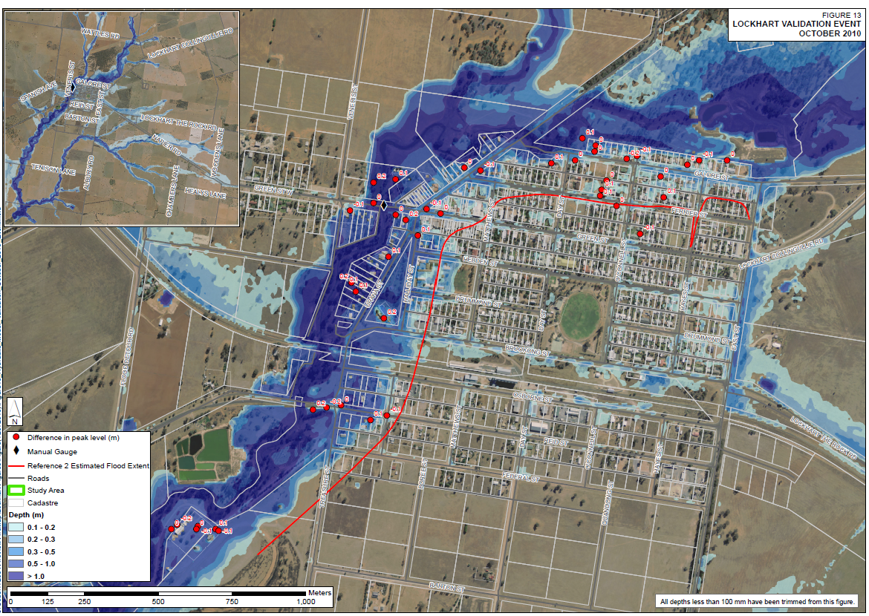
Figure 1.
Slope.
Part of this flooding is explained by the proximity to the Brookong Creek, and part is due to the gradient of close to 1% from the lowest points on the West to the highest point on the Eastern Edge.
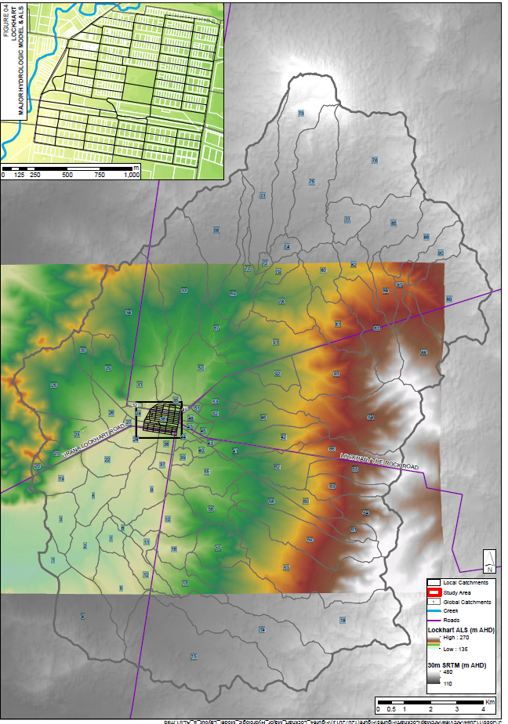
Figure 2
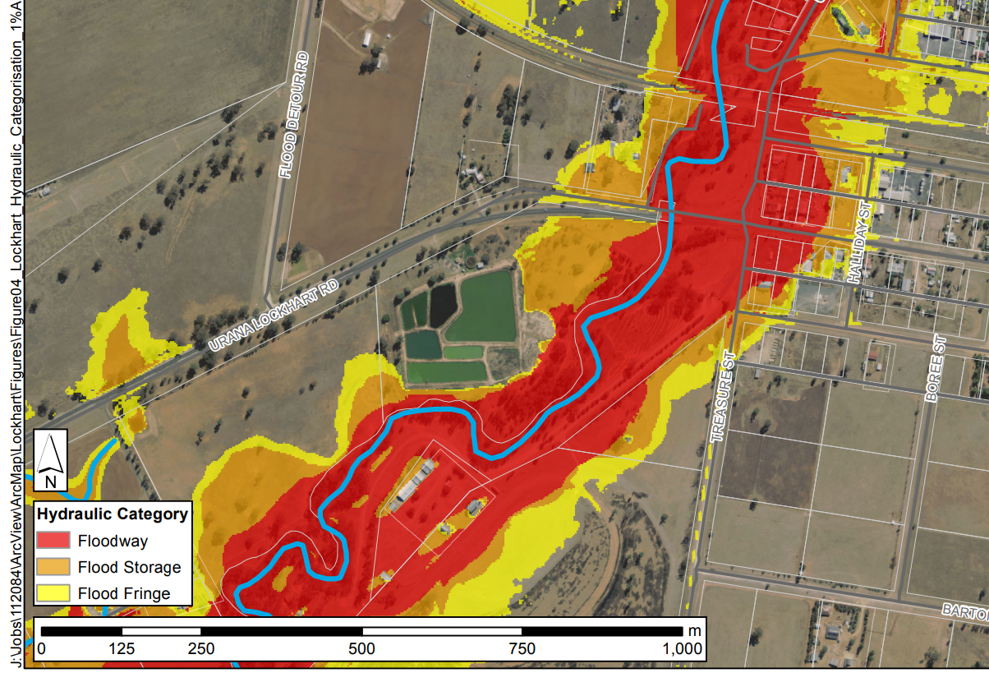
Figure 3
2 Blocks to the West shown as in floodway, Eastern block is half in flood storage on the North and in Flood Fringe in the south.
Below shows ability to implement a lower beam so all chemical is store 0.3m high, or even higher if necessary permanantly.
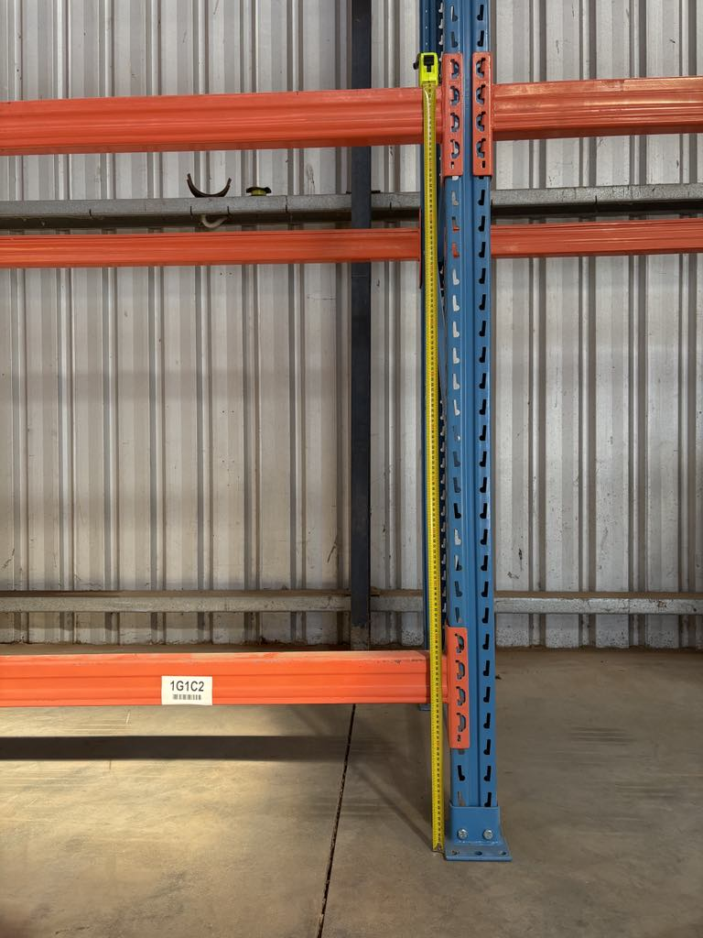
Bushfire
Riverina Bushfire Risk Management Plan, Overview of District.
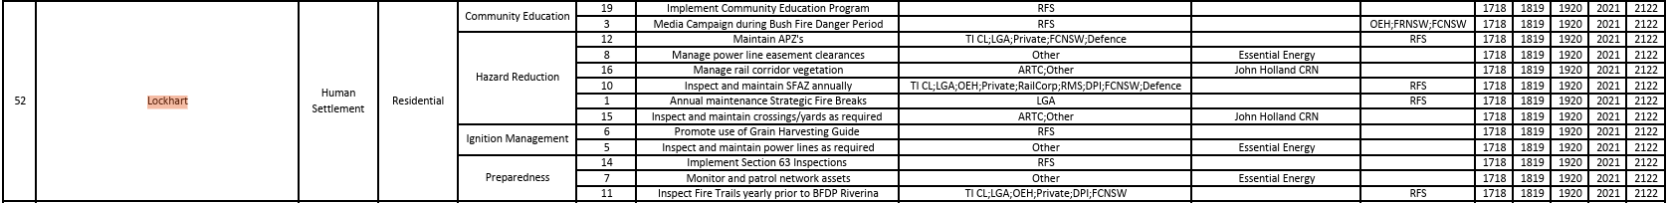
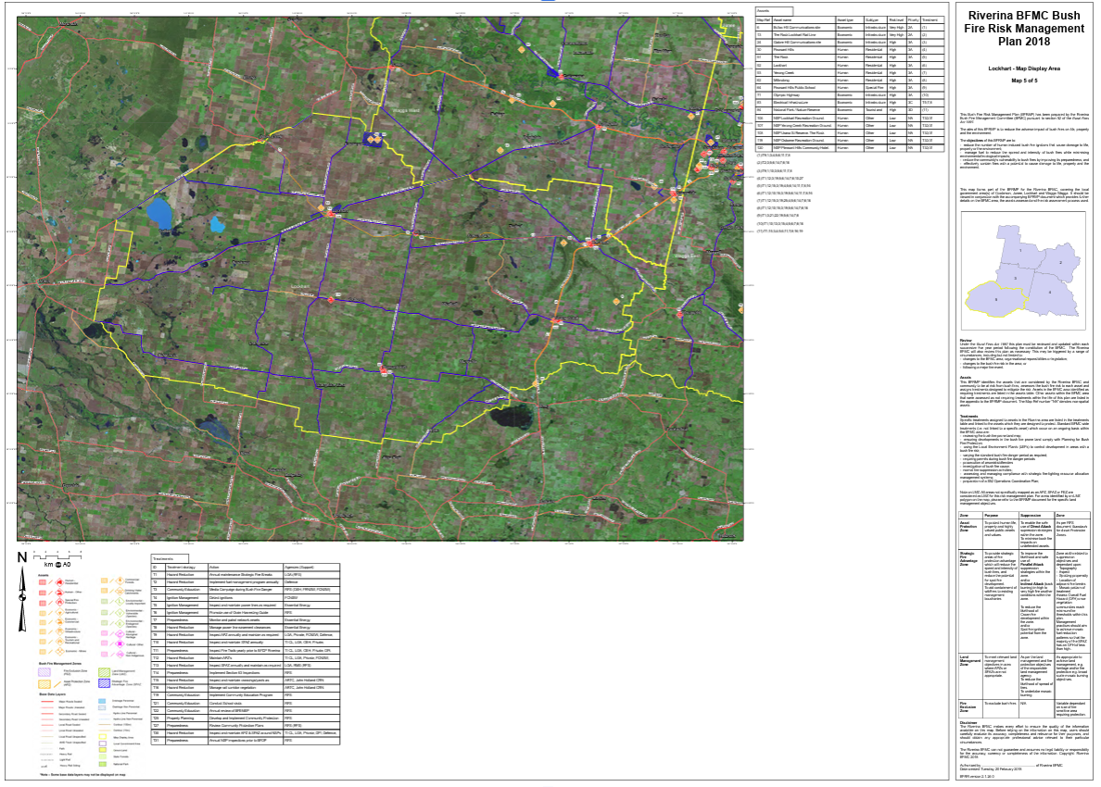

Overview of site, specific.
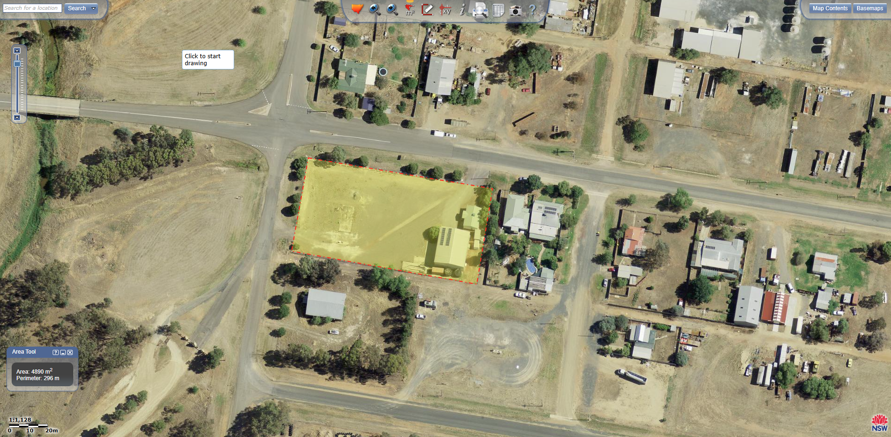
Bush Fire: a general term used to describe fire in vegetation, includes grass fire.
Assets on site or adjacent at risk of bushfire. Fence line, Sheds, Office, Rainwater Tanks, Trees, Grass and natural vegetation.
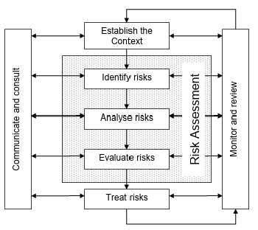
Management Strategies.
Grass on site will be kept at a low or nil level to minimise fuel load and chance of grass fire.
Site has been inspected by Wagga Fire and Security and installed appropriate new extinguishers, blankets and signage in shed and office.
Site Protection Plan: a fine scale document that that consists of map and preparation documents will be kept on hand. Including emergency assembly area.
Fire Fighting Equipment. As a part of the business, we are likely to retail fire fighting pumps and associated equipment and as such can utilise water carts and tanks on site in the event of a fire.
Risk Identification. We will continually monitor for risks increasing or decreasing such as native vegetation accumulating on or around out site, identify remove of remediate these risks with consultation to the appropriate authorities.

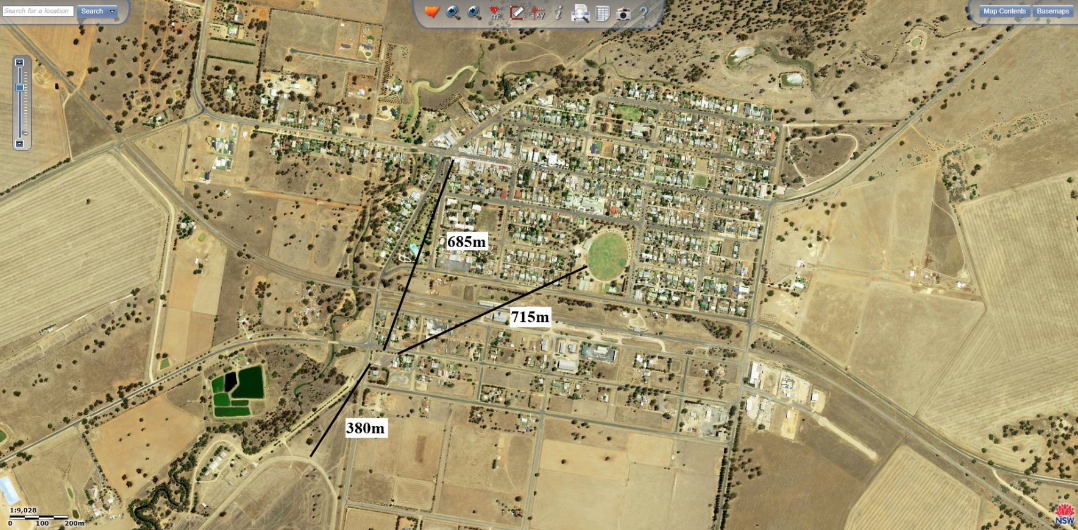
Proximity to shops, community and recreation facilities.

685m to closest shop on Green St.
715m to Recreation Ground.
380m to Racecourse / Show Grounds.
Our closest proximity to the community is two residential lots to the East.
The site is compatible with adjoining developments.

The site is suitable with local planning objects, after referencing the Local Strategic Planning Statement 2020 – 2040, especially under the LSPS Priorities of Growing a diverse economy and Strong, connected and healthy communities.
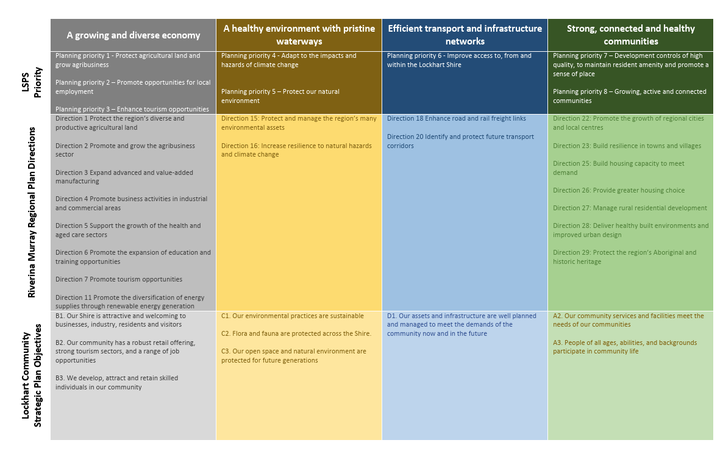
Planning priority 1 – Protect agricultural land and grow agribusiness sector and Planning Priority 2 – Promote opportunities for local employment will both be met by this new business, a locally, family owned and operated agribusiness.

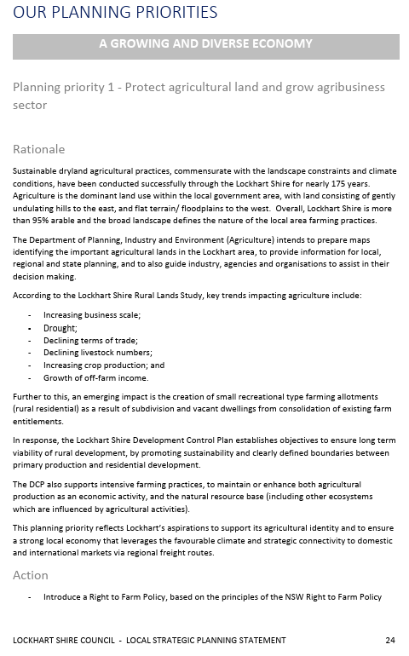
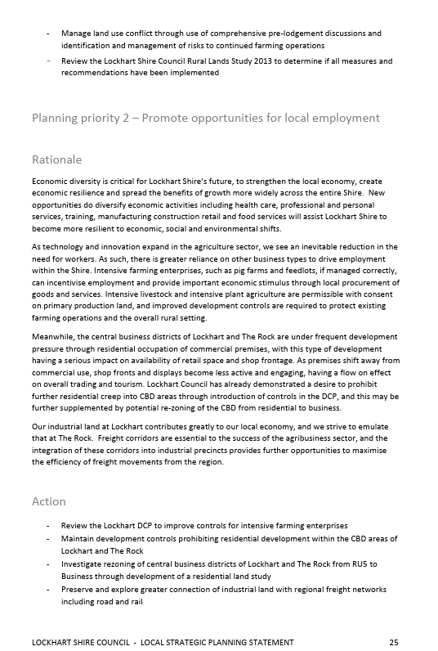
Size and Shape of allotment.
Shed and office are in good to excellent condition and are from 2005
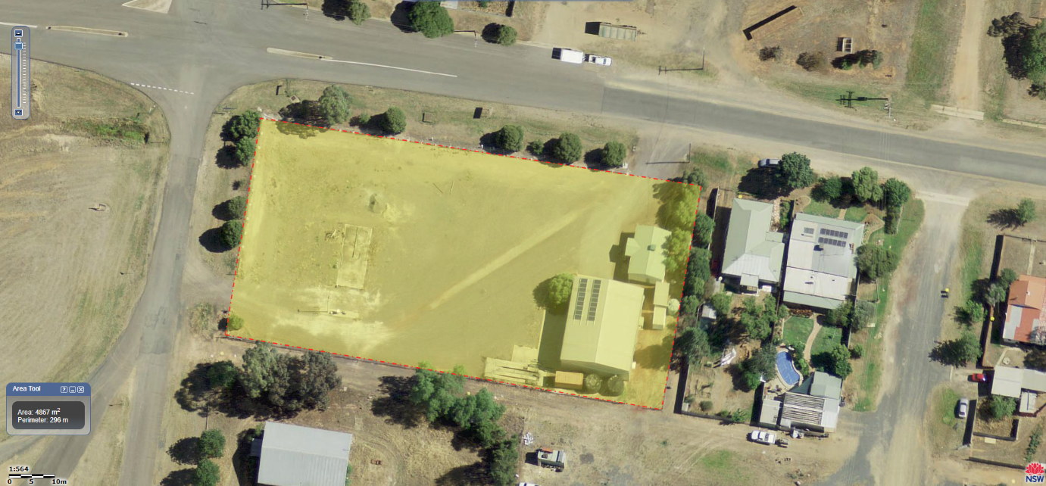
- Current and Previous Uses.
The previous use of the site was as a heavy haulage depot.
The present use has not yet commenced.
Adjoining land is vacant council land sloping to the Brookong Creek on the Western Edge.
Reid St on the Northern Edge adjoining land is general industrial.
Eastern adjoining blocks are residential.
Southern Edge adjoining blocks are vacant scout hall south west and general storage shed south east.
We are currently not aware of any potential contamination on the site.

- Operational Details.
Hours of operation initially will be 9-5 Monday to Friday, potentially extending those during busy seasons, predominantly during preparation for establishment of the cropping phase on farms.
Type of business: Agribusiness retail commensurate with and ag resellers currently in town Nutrien and Delta.
Number of staff: 2 current.
Hours and days of operation 9am-5pm Monday to Friday
Plant and Machinery: Forklift, HR single Curtain sider Truck, Utes.
Production Processes: Nil
Type and quantity of raw materials, finished products and waste products: Nil
Identify any proposed hazardous materials or processes: Processes Nil
Hazardous materials proposed include Schedule 5,6, and 7 chemicals. These will be stored in accordance with SDS and AgSafe requirements, when there is physical product present.
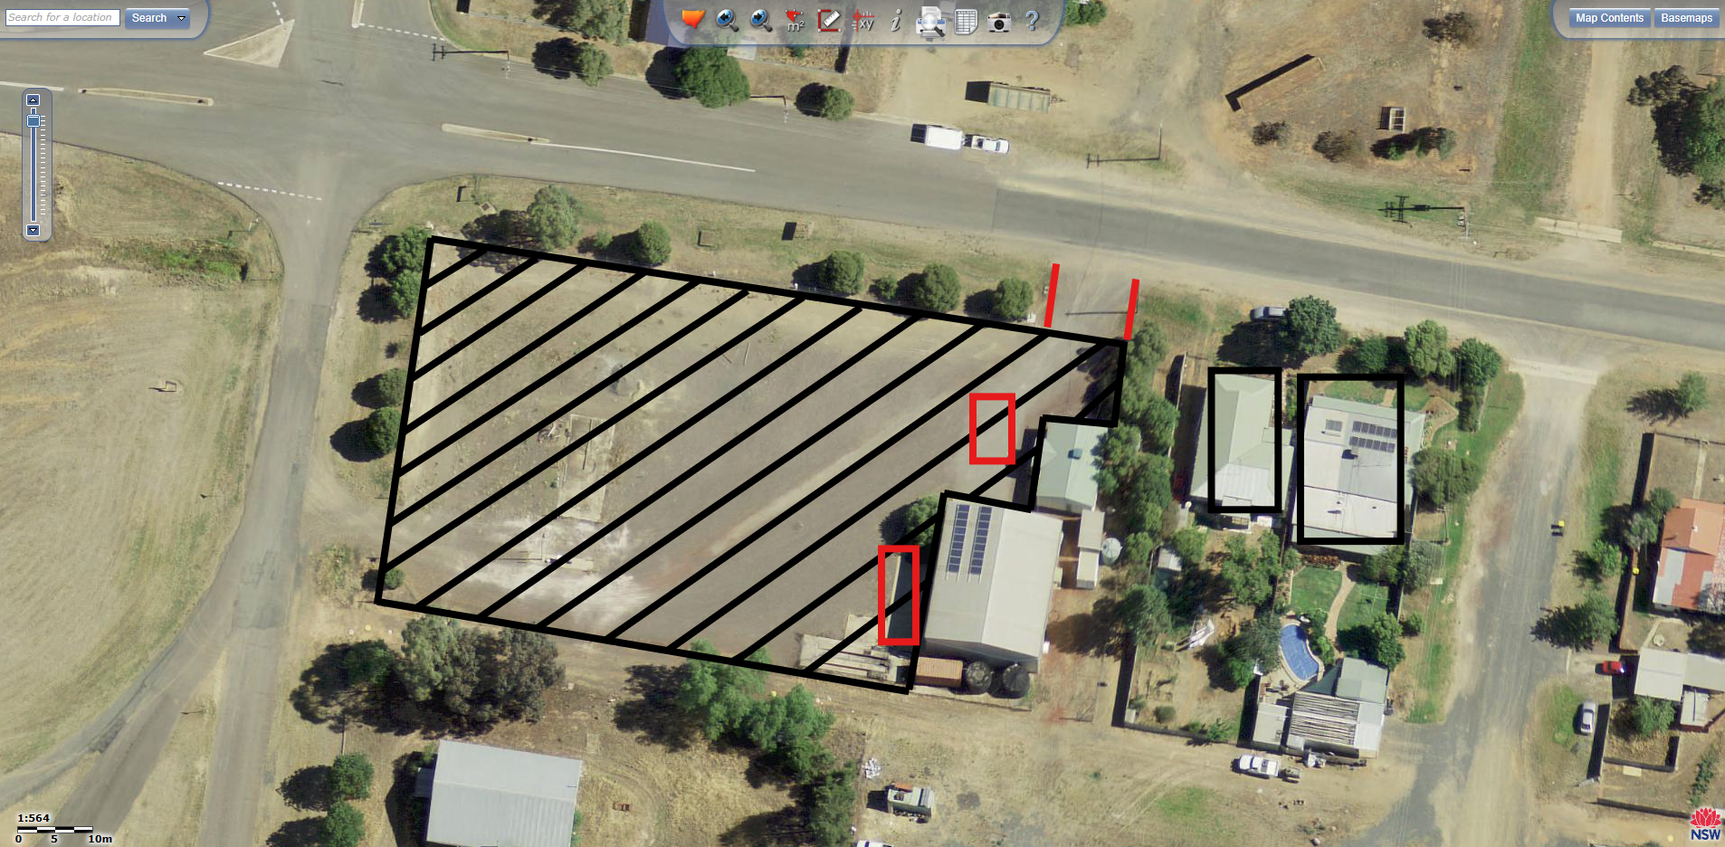
- Access and traffic.
Disability access. Completed installation of handles on front steps of office for increased disability access.
Pedestrian amenity. N/A.
Bicycle facilities. N/A.
Vehicle Access to public road. Access via double gate to REID St.
Parking on site. Large gravel yard, parking available for 15 vehicle, concrete apron on west of shed, Parking available for 4 vehicles, and option to park 2-3 vehicles in the shed.
Truck Park on concrete apron = 1 park
Parking calculations. 2 Staff in one vehicle most days = 2 parks
2 Staff in separate vehicles on occasional days = 3 parks
Potential for additional staff in additional vehicle = Max 4 parks
No major traffic generation.

- Air and Noise.
Proposed air and noise mitigation.
Gravel yard to mitigate any dust.
Operational hours between 9-5, occasionally from 8am to minimise noise.
Operational noise. N/A
Expected traffic is only 1-2 Utes every other day and the occasional MR truck plus occasional forklift use.
- Privacy, Views and Overshadowing.
There will be no structural changes to the site and so there will be no effects.

- Visual Privacy.
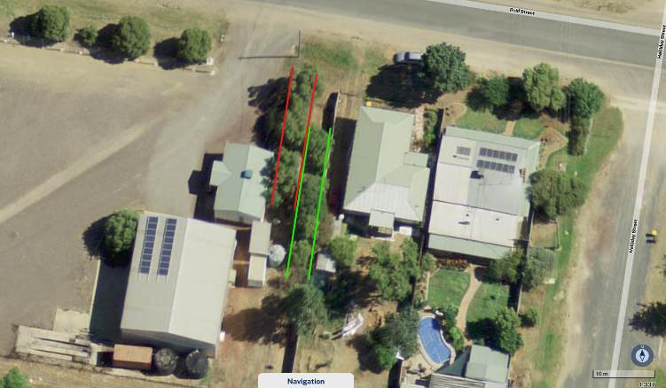
Window placement. Existing windows in demountable office on Eastern side facing neighbours, blinds can be drawn and there is a row of trees to be kept in place running north south between our security fence and the corrugated fence that almost completely obscure any vision between the blocks. Despite the removal of trees by the prior tenant (with or without council approval) that were between the demountable office and the border fence. The private residence to the East has not left it exposed. The row mentioned in the submission phase is not the row that we refer to and there is still a remaining row as outline in Green in the image below that as mentioned obscures almost completely any vision into adjoining blocks. There is also assurance to the community that in no way shape or form is there any interest in breach of anyone’s right to privacy, which will be maintained as a function of strict company policy.

Views between living rooms, and private yards of other dwellings. N/A
Use of screen planting walls or fences to improve privacy. N/A
Flood lights and light spillage. N/A

- Acoustic privacy.
Placement of active use outdoor areas relative to bedrooms marked in black stripes in markup above.
Separation of roads, parking areas and driveways (Marked in red existing driveways and parks)
Noise transmission between dwellings will be minimal with the majority of operational noise coming from a single fork lift operating at 85 decibels inside the shed and occasionally outdoors between the hours of 9am-5pm.
Measures to mitigate external noise sources are noted above as such.
- Views
Impact of proposed development on views from adjoining nearby properties. N/A
Design options for protecting views. N/A
Views from the proposed development. Unchanged

- Overshadowing
N/A

- Soil and Water
Water Supply. Rainwater tanks on site.
Sewerage disposal. Septic tank on site.
Drainage. Site will drain into adjacent table and stormwater drains in the directions noted below.
Flooding. As above in section 1
Erosion and sediment control. Site is gravelled and packed and on very minimal gradient to minimise all erosion and sediment.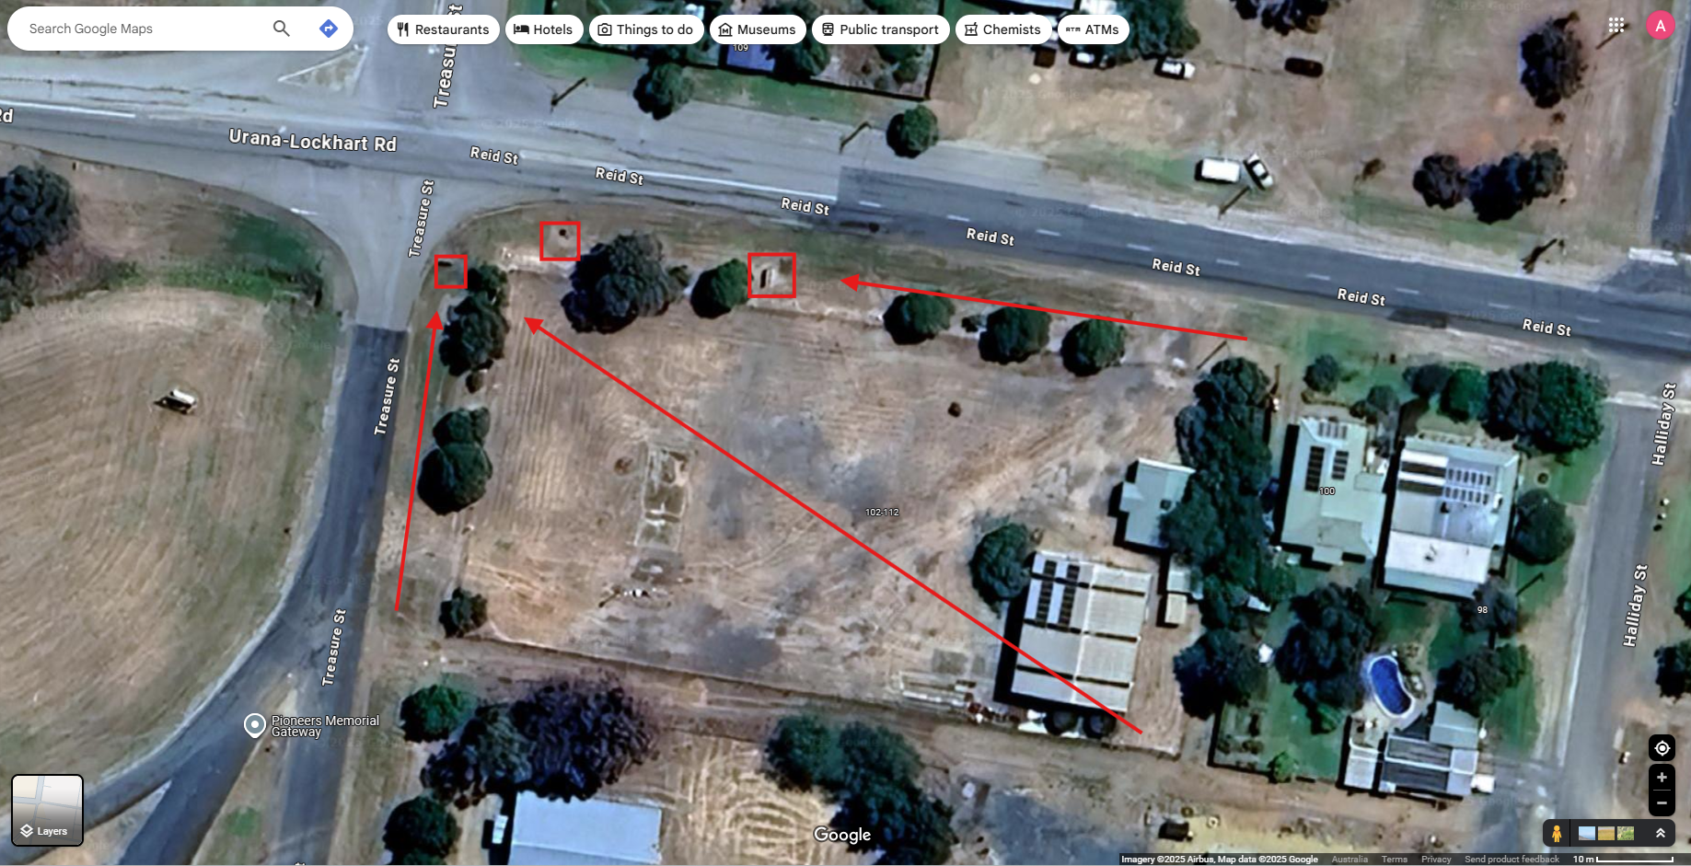

- Heritage.
N/A
- Flora and Fauna.
N/A
- Waste.
Proposal will minimise waste using recycling of cardboards, glass and aluminium.
- Energy.
Minimal staff using natural sunlight in office.
Shed had translucent corrugated strips to allow natural sunlight and avoid lighting.
Shed has solar panels installed.
- SafeWork Practices.
Jason Maynard from SafeWork NSW department of customer service has been offered any help or advice he can to help identify and mitigate any practices for the business to conduct work safely. These include his help on appropriate signage for speed limits, pedestrian control such as where truck drivers should stand during loading and unloading.
On 1st of May I attended an online webinar for an Introduction Work Health and Safety and it has given me great resources to draw on to improve our safe work practices.
Examples of this include implanting the following frame work for Manging risks and hazards.
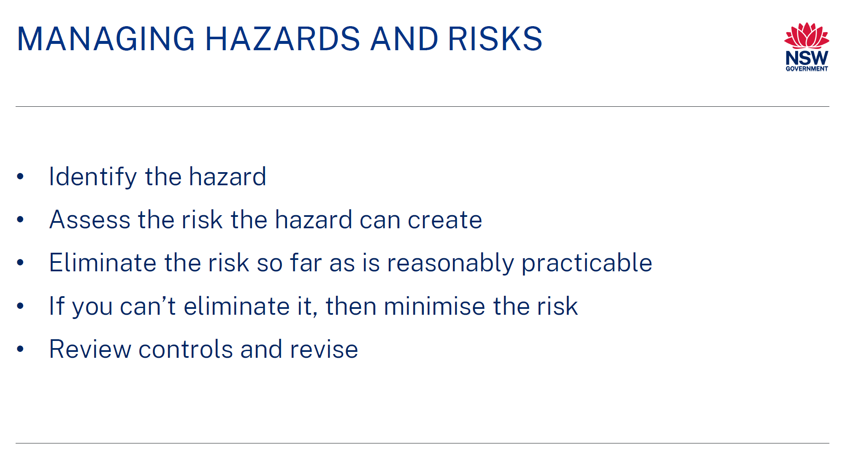
An example of this being plans to increase signage and outlined traffic management plan to effectively manage vehicle and pedestrian movement on site.
